**DAY 6- CSS (Color, Backgrounds, Navigation Bar)**

https://lh6.googleusercontent.com/pzfkpYzj_xNKuCIRaMdGOcJRGHimowNa5u7Ned4rI9rrL8AGediPxVgoTzYM65B3F7T2wKnzzs4NN42aMrsGf_ZZvSDkx9V2RHZ5SJ6YjjldEA7E9x9SwUSXZmLWBKV9rfHuNRbkG3bXpFexSg

**Refresh yesterday’s Class-10 Minutes**

1. To select an element with a specific id, which character is used
2. &
3. $
4. #
5. @

**Answer: - c**

Example:-

#p1 {

text-align: center;

color: red;

}

1. What are the three ways to insert CSS in HTML documents?

**Answer: -** Inline CSS, Internal CSS, External CSS

1. Correct the HTML code

<html>

<head>

<link rel="stylesheet" type="text/css" href="mystyle.html">

</head>

<h1>This is a heading</h1>

<p>This is a paragraph.</p>

</body>

</html>

**Answer :-** href=”mystyle.css”, <body>

**Lecture on CSS Colors & CSS Backgrounds-30 Minutes**

**CSS Colors**

* a valid color name - like "red"
* an RGB value - like "rgb(255, 0, 0)"

rgb(0,0,0)= Black

rgb(255,255,255)= White

* a HEX value - like "#ff0000"

#000000= Black

#FFFFFF= White

**CSS Backgrounds**

* **Background Color**

The background-color property specifies the background color of an element.

body {  
    background-color: lightblue;  
}

## Background Image

The background-image property specifies an image to use as the background of an element. By default, the image is repeated so it covers the entire element.

body {  
    background-image: url("bk.jpg");  
}

**Activity based on above lecture-1 Hour**

**CSS COLOR**

<!DOCTYPE html>

<html>

<body>

<h2>RGB Color Examples</h2>

<h2 style="color:rgb(255, 0, 0)">

Text-color set by using rgb(255, 0, 0)

</h2>

<h2 style="color:rgb(0, 255, 0)">

Text-color set by using rgb(0, 255, 0)

</h2>

<h2 style="color:blue;">

Blue text-color

</h2>

<h2 style="color:orange">

Orange text-color

</h2>

<h2 style="color:#FFFF00">

Text-color set by using #FFFF00

</h2>

<h2 style="color:#00FFFF">

Text-color set by using #00FFFF

</h2>

</body>

</html>

**OUTPUT**

## RGB Color Examples

## Text-color set by using rgb(255, 0, 0)

## Text-color set by using rgb(0, 255, 0)

## Blue text-color

## Orange text-color

## Text-color set by using #FFFF00

## Text-color set by using #00FFFF

## CSS BACKGROUND COLOR

<!DOCTYPE html>

<html>

<body>

<h2>HEX Color Examples</h2>

<h2 style="background-color:#FF0000">

Background-color set by using #FF0000

</h2>

<h2 style="background-color:#00FF00">

Background-color set by using #00FF00

</h2>

<h2 style="background-color:#0000FF">

Background-color set by using #0000FF

</h2>

<h2 style="background-color:#FFA500">

Background-color set by using #FFA500

</h2>

<h2 style="background-color:#FFFF00">

Background-color set by using #FFFF00

</h2>

<h2 style="background-color:#00FFFF">

Background-color set by using #00FFFF

</h2>

</body>

</html>

## OUTPUT

## HEX Color Examples

## Background-color set by using #FF0000

## Background-color set by using #00FF00

## Background-color set by using #0000FF

## Background-color set by using #FFA500

## Background-color set by using #FFFF00

## Background-color set by using #00FFFF

**CSS Background Image**

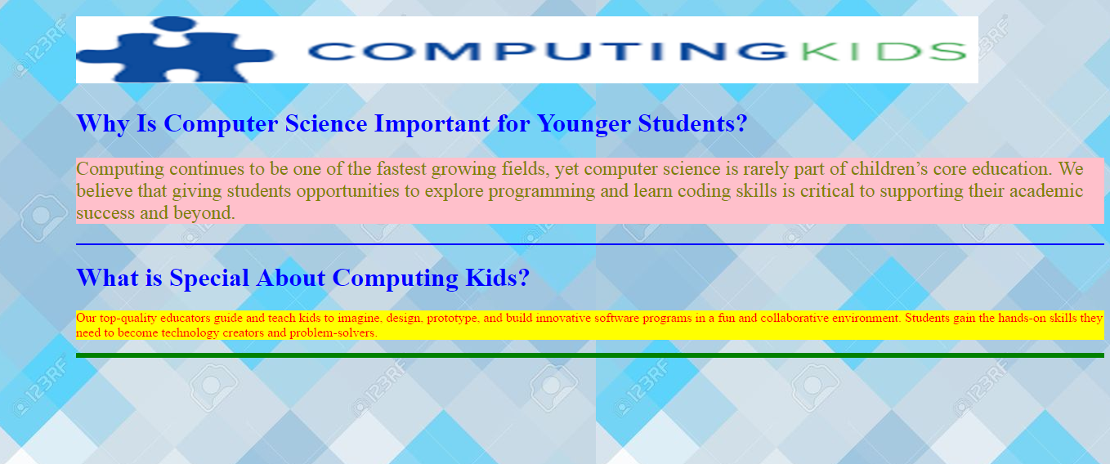

<!DOCTYPE html>

<html>

<head>

<style>

body {

background-image: url("bk.jpg");

margin-left:100px;

}

h1{

color:blue;

}

hr{

border: 1px solid blue;

}

#hr1{

border: 3px solid green;

}

</style>

</head>

<body>

<h1><img src="ComputingKids.png" alt="image" width="1104" height="82"></h1>

<h1>

Why Is Computer Science Important for Younger Students?

</h1>

<p style="color:olive; background-color:pink;font-size:x-large;">

Computing continues to be one of the fastest growing fields, yet computer science is rarely part of children’s core education.

We believe that giving students opportunities to explore programming and learn coding skills is critical to supporting their academic success and beyond.

</p>

<hr>

<h1>

What is Special About Computing Kids?

</h1>

<p style="color:red; background-color:yellow;">

Our top-quality educators guide and teach kids to imagine, design, prototype, and build innovative software programs in a fun and collaborative environment.

Students gain the hands-on skills they need to become technology creators and problem-solvers.

</p>

<hr id="hr1">

</body>

</html>

**CSS Navigation Bar**

## Navigation Bars-15 Minutes

Having easy-to-use navigation is important for any web site. With CSS you can transform boring HTML menus into good-looking navigation bars.

## Navigation Bar = List of Links

A navigation bar needs standard HTML as a base. A navigation bar is basically a list of links, so using the <ul> and <li> elements makes perfect sense:

## Vertical Navigation Bar

To build a vertical navigation bar, you can style the <a> elements inside the list

<head>

<style>

ul {

list-style-type: none;

margin: 0;

padding: 0;

}

li a {

display: block;

width: 60px;

background-color: #dddddd;

}

</style>

</head>

<body>

<ul>

<li><a href="#home">Home</a></li>

<li><a href="#news">News</a></li>

<li><a href="#contact">Contact</a></li>

<li><a href="#about">About</a></li>

</ul>

</body>

* display: block; - Displaying the links as block elements makes the whole link area clickable (not just the text), and it allows us to specify the width (and padding, margin, height, etc. if you want)
* width: 60px; - Block elements take up the full width available by default. We want to specify a 60 pixels width

**Create a basic vertical navigation bar with a gray background color and change the background color of the links when the user moves the mouse over them?**

ul {  
    list-style-type: none;  
    margin: 0;  
    padding: 0;  
    width: 200px;  
    background-color: #f1f1f1;  
}  
  
li a {  
    display: block;  
    color: #000;  
    padding: 8px 16px;  
    text-decoration: none;  
}  
  
/* Change the link color on hover */  
li a:hover {  
    background-color: #555;  
    color: white;  
}

## Vertical Navigation Bar (Activity)-30 Minutes

## [Home](https://www.w3schools.com/css/tryit.asp?filename=trycss_navbar_vertical#home)

[News](https://www.w3schools.com/css/tryit.asp?filename=trycss_navbar_vertical#news)

[Contact](https://www.w3schools.com/css/tryit.asp?filename=trycss_navbar_vertical#contact)

[About](https://www.w3schools.com/css/tryit.asp?filename=trycss_navbar_vertical#about)

A background color is added to the links to show the link area.

Notice that the whole link area is clickable, not just the text.

## CODE

<!DOCTYPE html>

<html>

<head>

<style>

ul {

list-style-type: none;

margin: 0;

padding: 0;

}

li a {

display: block;

width: 60px;

background-color: #f1f1f1;

}

</style>

</head>

<body>

<ul>

<li><a href="#home">Home</a></li>

<li><a href="#news">News</a></li>

<li><a href="#contact">Contact</a></li>

<li><a href="#about">About</a></li>

</ul>

<p>A background color is added to the links to show the link area.</p>

<p>Notice that the whole link area is clickable, not just the text.</p>

</body>

</html>

**Create a basic vertical navigation bar with a gray background color and change the background color of the links when the user moves the mouse over them?**

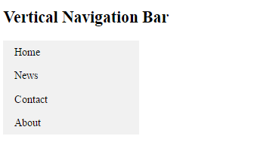

## CODE

<!DOCTYPE html>

<html>

<head>

<style>

ul {

list-style-type: none;

margin: 0;

padding: 0;

width: 200px;

background-color: #f1f1f1;

}

li a {

display: block;

color: #000;

padding: 8px 16px;

text-decoration: none;

}

/* Change the link color on hover */

li a:hover {

background-color: #555;

color: white;

}

</style>

</head>

<body>

<h2>Vertical Navigation Bar</h2>

<ul>

<li><a href="#home">Home</a></li>

<li><a href="#news">News</a></li>

<li><a href="#contact">Contact</a></li>

<li><a href="#about">About</a></li>

</ul>

</body>

</html>

**Horizontal Navigation Bar-15 Minutes**

There are two ways to create a horizontal navigation bar. Using **inline** or **floating** list items.

### **Inline List Items**

One way to build a horizontal navigation bar is to specify the <li> elements as inline

li {  
    display: inline;  
}

* display: inline; - By default, <li> elements are block elements. Here, we remove the line breaks before and after each list item, to display them on one line

### **Floating List Items**

Another way of creating a horizontal navigation bar is to float the <li> elements, and specify a layout for the navigation links:

li {  
    float: left;  
}  
  
a {  
    display: block;  
    padding: 8px;  
    background-color: #dddddd;  
}

* float: left; - use float to get block elements to slide next to each other
* display: block; - Displaying the links as block elements makes the whole link area clickable (not just the text), and it allows us to specify padding (and height, width, margins, etc. if you want)
* padding: 8px; - Since block elements take up the full width available, they cannot float next to each other. Therefore, specify some padding to make them look good
* background-color: #dddddd; - Add a gray background-color to each a element

**Tip:** Add the background-color to <ul> instead of each <a> element if you want a full-width background color

**Create a basic horizontal navigation bar with a dark background color and change the background color of the links when the user moves the mouse over them?**

ul {  
    list-style-type: none;  
    margin: 0;  
    padding: 0;  
    overflow: hidden;  
    background-color: #333;  
}  
  
li {  
    float: left;  
}  
  
li a {  
    display: block;  
    color: white;  
    text-align: center;  
    padding: 14px 16px;  
    text-decoration: none;  
}  
  
/* Change the link color to #111 (black) on hover */  
li a:hover {  
    background-color: #111;  
}

**Add an "active" class to the current link to let the user know which page he/she is on:**

.active {  
    background-color: #4CAF50;  
}

## Horizontal Navigation Bar (Activity)-30 Minutes

### **Inline List Items**



**CODE**

<!DOCTYPE html>

<html>

<head>

<style>

ul {

list-style-type: none;

margin: 0;

padding: 0;

}

li {

display: inline;

}

</style>

</head>

<body>

<ul>

<li><a href="#home">Home</a></li>

<li><a href="#news">News</a></li>

<li><a href="#contact">Contact</a></li>

<li><a href="#about">About</a></li>

</ul>

</body>

</html>

### **Floating List Items**

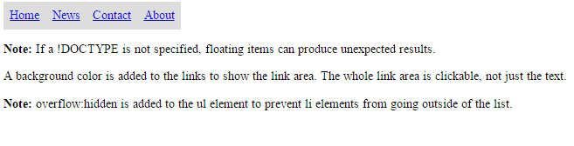

**CODE**

<!DOCTYPE html>

<html>

<head>

<style>

ul {

list-style-type: none;

margin: 0;

padding: 0;

overflow: hidden;

}

li {

float: left;

}

li a {

display: block;

padding: 8px;

background-color: #dddddd;

}

</style>

</head>

<body>

<ul>

<li><a href="#home">Home</a></li>

<li><a href="#news">News</a></li>

<li><a href="#contact">Contact</a></li>

<li><a href="#about">About</a></li>

</ul>

<p><b>Note:</b> If a !DOCTYPE is not specified, floating items can produce unexpected results.</p>

<p>A background color is added to the links to show the link area. The whole link area is clickable, not just the text.</p>

<p><b>Note:</b> overflow:hidden is added to the ul element to prevent li elements from going outside of the list.</p>

</body>

</html>

**Create a basic horizontal navigation bar with a dark background color and change the background color of the links when the user moves the mouse over them?**



**CODE**

<!DOCTYPE html>

<html>

<head>

<style>

ul {

list-style-type: none;

margin: 0;

padding: 0;

overflow: hidden;

background-color: #333;

}

li {

float: left;

}

li a {

display: block;

color: white;

text-align: center;

padding: 14px 16px;

text-decoration: none;

}

li a:hover:not(.active) {

background-color: #111;

}

.active {

background-color: #4CAF50;

}

</style>

</head>

<body>

<ul>

<li><a class="active" href="#home">Home</a></li>

<li><a href="#news">News</a></li>

<li><a href="#contact">Contact</a></li>

<li><a href="#about">About</a></li>

</ul>

</body>

</html>